YEAR 10 SCIENCE
PHYSICAL SCIENCES
PHYSICS DATA SHEET

sp
d
t
Speed 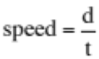

v
s
t

Velocity 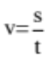

Acceleration 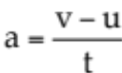

Equations of motion
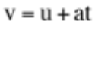

Force F = ma
m
F
a

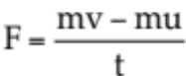
m
F_{w}ww
a

Weight F_{w} = mg

Acceleration due to gravity g = 9.80 ms⁻²

Converting kmh⁻¹ to ms⁻¹ Divide the speed in kmh⁻¹ by 3.6 to get the speed in ms⁻¹.

